I expect to benifit by inculcating global leadership traits and leverage my ability to adopt and assimilate knowledge .I hope to thrive in this experiential system whilst relying on these core competencies to be an

Active participate in the room.

**HTML CSS BOOTSTRAP**

Liaqat Ali Degree college RWP.

**UNIVERSITY OF NUML**

**Bachelor in Computer Science (Continuing)**

**2020**

Reading

Writing

Music

Photography

Rawalpindi

+923425477337

Shamk5445@gmail.com

**EXPERIENCE**

**EDUCATION**

**HOBBIES**

**CONTACT**

**PROFILE**

**Ahtesham Shakeel**

CURICULUM VITAE

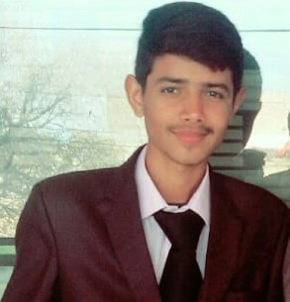

**College**

**ICS**

**2018-2019**

391-mail4.png

067-phone.png

001-home.png

**Prodesign Inc.**

**Front end Developer**

032-book.png016-camera.png

006-pencil.png018-music.png